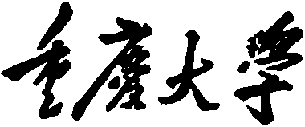 

**Personal Learning Portfolio**

**Course： English Academic Writing Teacher： Zhang Mei**

**Class： 002 Major： Computer Science**

**Name： Wen Hongbing Student Number： 20214590**

**Class Time： 2023.02-2023.07**

**Grade：**

|  |  |  |
| --- | --- | --- |
| **Self** | **Teaching Assistant** | **Teacher** |
| **9.5** |  |  |

**Comments：**

**Teacher (Signature)**

**Contents**

# Week 12

1. **My learning**

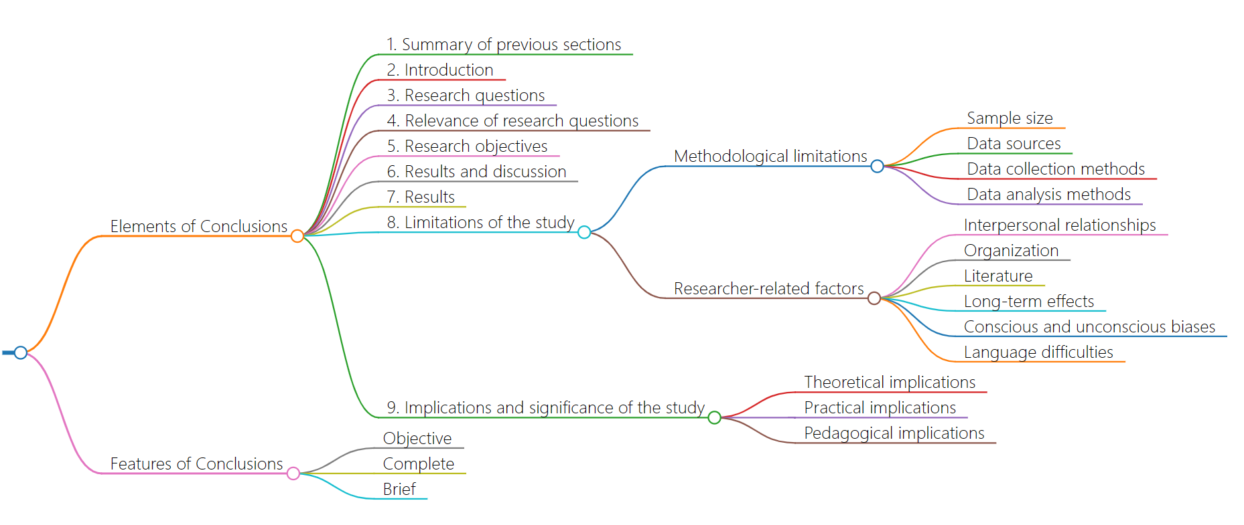

1. **Learning outcomes**

* The elements of the conclusion include preface, research questions, research objectives, results and discussion, results, research limitations, etc. These elements need to be presented clearly and coherently in the conclusion.
* The conclusion of this paper is objective, comprehensive and concise. This means that we need to present the findings and conclusions comprehensively, based on facts, and expressed as concisely as possible.
* In future paper writing, we can refer to these elements and characteristics to ensure that our conclusion section presents the results and conclusions clearly and methodically.
* We can use the elements of the conclusion as a framework to organize our conclusion, while focusing on the characteristics of the conclusion, so that readers can better understand our research results and conclusions.

1. **My behavior and attitude**

* Pay attention to methods and efficiency,we should pay attention to methods and adopt scientific learning methods and skills to improve learning efficiency.
* Improve your attitude and enthusiasm to answer questions in class and make persistent efforts.

1. **Improvement**

Exercise regularly: Proper exercise can relax the brain, relieve tension and anxiety, and improve thinking ability. Schedule some time each day for light aerobic exercise, such as walking and jogging.

# Week 13

1. **My learning**

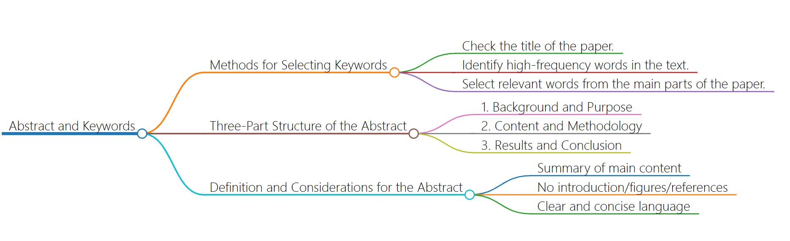

1. **Learning outcomes**

* The selection of appropriate keywords is essential for making a paper discoverable by search engines and other scholarly resources. By using relevant and specific keywords, authors can help readers find their work more easily. The methods for selecting keywords, such as checking the title, identifying high-frequency words, and selecting relevant words from the main parts of the paper, can help authors choose the most appropriate keywords.
* The three-part structure of the abstract includes background and purpose, content and methodology, and results and conclusion.In the background and purpose section, authors can emphasize the importance and necessity of their research, as well as elaborate on the problems and gaps they are addressing. In the content and methodology section, authors can briefly introduce their research object, methods, and experimental design.In the results and conclusion section, authors can emphasize the contribution and significance of their research and provide directions and suggestions for future research.
* When writing an abstract, authors should use clear and concise language, avoid professional jargon and complex structures, and provide a brief summary of the main content of their paper.The abstract should not include an introduction, figures, or references, and should be limited to a specific word count, depending on the requirements of the journal or conference.

1. **My behavior and attitude**

Compared with last week, my class attitude and class quality have been improved. Good concentration and endurance, showing high concentration and endurance in the learning process, able to concentrate on completing tasks.

1. **Improvement**

Hope to continue to work hard next week, not slack off in extracurricular studies